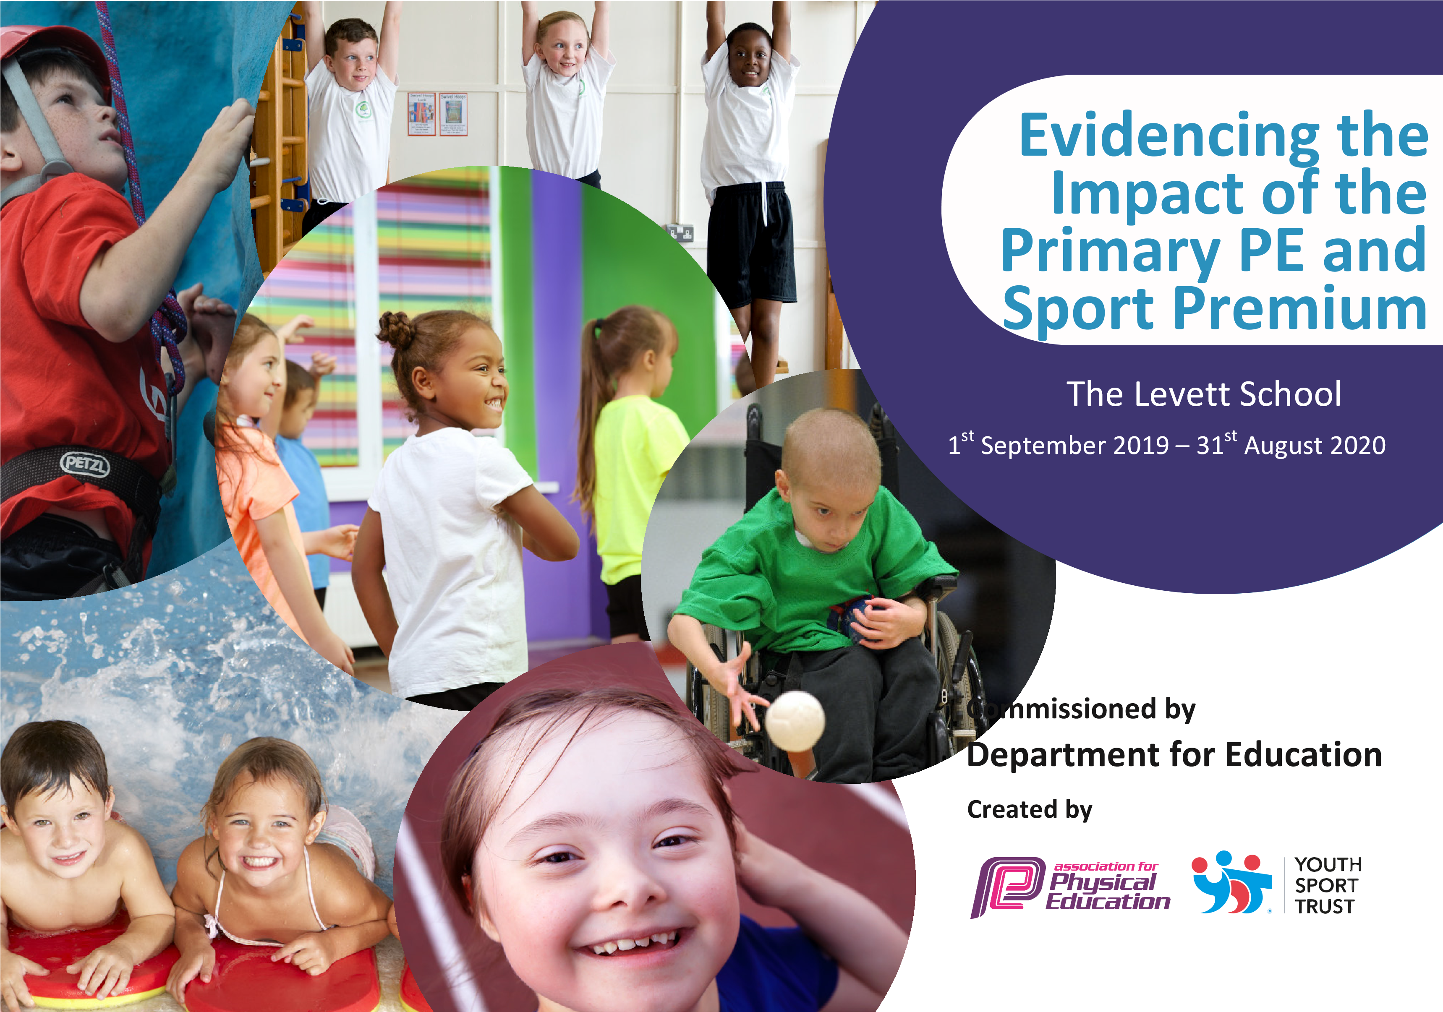

The Levett School

Academic Year 2024 - 2025

|  |  |  |  |
| --- | --- | --- | --- |
| Key achievements to date: | Areas for further improvement and baseline evidence of need: | | |
| Purchasing more appropriate resources.  Outdoor activity resources purchased.  CPD session for staff in Gymnastics.  PE curriculum overview and assessment criteria written and in place. Audit of Teacher confidence in different activities so as to plan appropriate CPD.  PE lessons increased from 30 to 40 minutes.  OAA activities introduced.  Outdoor gym facilities to meet the needs of all the pupils.  An external coaching team facilitating personalised PE sessions to all the children on a weekly basis.  An external coaching team to support the organising and delivery of a yearly competitive sporting event for all pupils.  Daily HALT sessions to focus on ACTIVE children. | Continue to purchase resources to improve and develop the pupils’ physical literacy and education.  To broaden the range of activities for pupils.  To utilise the specialist PE teacher to team-teach with staff to upskill and provide CPD.  To develop more structured physical activities at break and lunch time.  To continue to develop the HALT active group timetable offering a broad range of physical activities. | | |
| Meeting national curriculum requirements for swimming and water safety | | Please complete all of the below: | |
|  | | Single registered pupils | All pupils |
| What percentage of your Year 6 pupils could swim competently, confidently and proficiently over a distance of at least 25 metres when they left your primary school at the end of last academic year? | | 3/6 | 80% |
| What percentage of your Year 6 pupils could use a range of strokes effectively [for example, front crawl, backstroke and breaststroke] when they left your primary school at the end of last academic year? | | 100% | 80% |
| What percentage of your Year 6 pupils could perform safe self-rescue in different water-based situations when they left your primary school at the end of last academic year? | | 100% | 100% |
| Schools can choose to use the Primary PE and Sport Premium to provide additional provision for swimming but this must be for activity **over and above** the national curriculum requirements. Have you used it in this way? | | We did offer swimming to all year groups not just the Yr 5 pupils in the Autumn Term | |

|  |  |  |  |  |
| --- | --- | --- | --- | --- |
| Action Plan and Budget Tracking | | | | |
| **Academic Year:** 2024 / 2025 | **Total fund allocated**: £10,995 | **Date Updated:**  May 25 | |  |
| **Key indicator 1:** The engagement of all pupils in regular physical activity – Chief Medical Officer guidelines recommend that primary school children undertake at least 60 minutes of physical activity a day in school | | | | Percentage of total allocation: |
| School focus with clarity on intended **impact on pupils**: | Actions to achieve: | Funding allocated: | Evidence and impact: | Sustainability and suggested next steps: |
| **To increase participation levels in physical activity for all pupils, working towards 60 minutes each day.** | Increase the amount of weekly of PE lessons ensuring all children are provided with 75 minutes’ worth of structured PE weekly.  Movement of the outdoor gym facilities from one setting to another.  Ensure all pupils get an active, structured outdoor break-time and lunch break.  All children to be given the opportunity to access HALT active group on a daily basis. | £7800  £3195 | All children have a timetabled PE slot with an external agency for 45minutes on a weekly basis.  All children are timetabled an additional 30-minute PE session facilitated by the class teacher.  Trim Trail to be used for PE, Breaks, Lunches and sensory activities op help pupils stay active and regulate behaviour.  Pupils get at least one active playtime outside each day.  Pupils can access the outdoor gym facilities at break, PE, sensory activities and to regulate behaviours. | Purchase equipment solely for use at break-times.  PE and structured breaks are a major focus in the timetable.  Sport interventions to help regulate behaviour.  HALT active groups to continue to ensure children get the interventions they need. |
| **Key indicator 2:** Raising the profile of PE and sports across the school, to support whole school improvement. | | | | Percentage of total allocation: |
| School focus with clarity on intended **impact on pupils**: | Actions to achieve: | Funding allocated: | Evidence and impact: | Sustainability and suggested next steps: |

|  |  |  |  |  |  |  |
| --- | --- | --- | --- | --- | --- | --- |
| **To develop healthy lifestyles through promotion of healthy eating and new activities.** | All pupils have taken part in a Healthy Lifestyle week during National School Sports Week.  Fruit available in every classroom throughout the day.  PSHE sessions solely focusing on living a healthy lifestyle.  Gardening programmes allowing pupils the opportunity to grow and maintain their own vegetables.  Parental engagement days focusing on stepping out of your comfort zone and trying new challenges. | | | £1,500 | Pupils enjoyed a week of sport and healthy eating.  Increase in pupils eating fruit.  Improvement of pupil’s attitudes to try new challenges.  Supportive parents.  Increased engagement in activities. | Seal activities where families come in and create healthy meals/ snacks.  Join School Games and access inter-school competitions.  More of an opportunity to grow a selection of fruit and vegetables on the school grounds. |
| **Key indicator 3:** Increased confidence, knowledge and skills of all staff in teaching PE and sport | | | | | | Percentage of total allocation: |
| School focus with clarity on intended **impact on pupils**: | | Actions to achieve: | Funding allocated: | | Evidence and impact: | Sustainability and suggested next steps: |
| **To improve the teaching of PE for staff and the learning experience of all pupils.** | | Staff to follow Primary Steps in PE Schemes of work purchased in a previous year.  PE specialist supports with areas they need help in and models’ good lessons.  Staff to observe good practice from the external coaches.  Ensure the curriculum offers a broad range of activities. |  | | Staff supported in the delivery of PE sessions which raised staff skill levels.  Pupils more engaged and fewer opted out.  Staff have a range of resources at fingertips and lesson plans to give them confidence in delivering PE lessons. | Ensure a rolling programme of support for staff.  Continue to use PE Coordinator in delivery of some staff CPD. |
| **Key indicator 4:** Broader experience of a range of sports and activities offered to all pupils | | | | | | Percentage of total allocation: |
| School focus with clarity on intended **impact on pupils:** | | Actions to achieve: | Funding allocated: | | Evidence and impact: | Sustainability and suggested next steps: |
| **To provide pupils with a greater breadth of sporting opportunities.** | | Fishing 4-week programme to be made available for a selection of pupils.  Combination goal posts to be fitted on the main playground allowing children a broader sporting opportunity.  Timetables updated regularly to ensure a vast range of activities are available during HALT and structured interventions.  Regular wellbeing walks and sporting opportunities to be timetabled in every half term for all pupils. |  | | Currently being organised for children to access during Summer 2 term.  Pupils self-regulating and self-directing to use the outdoor gym facilities during free time and during time out.  Pupils can now use an appropriate football net and basketball hoop during break time.  Pupils are developing a greater understanding of daily exercise and the benefits of this. | Increase the range of activities offered.  Join School Games and access inter-school competitions. |
| **Key indicator 5:** Increased participation in competitive sport | | | | |  | Percentage of total allocation: |
| School focus with clarity on intended **impact on pupils**: | | Actions to achieve: | Funding allocated: | | Evidence and impact: | Sustainability and suggested next steps: |
| **For all pupils to take part in a school sports day where the winners receive certificates.** | | For all pupils to take part in a competitive sports day.  To receive certificates for achievement and participation.  To experience small sided competitive games during PE lessons.  Parents to be invited to sports day.  Winter sports day to be arranged to give pupils an additional competitive sporting opportunity. |  | | All classes took part in races, throwing and jumping events and received winner certificates.  There were fewer incidences of behaviour during this day.  Pupils introduced to winning and losing during PE lessons. | Intra school competitions to be added to calendar  Inter school competitions to be accessed e.g. School Games. |