**The Levett School**

**Absconding Procedure**

|  |  |
| --- | --- |
| ***Policy agreed by Management Committee on:*** | 01.07.2025 |
| ***Review date for Management Committee:*** | 01.07.2027 |
| ***Allocated Group/Person to Review:*** | Hayley Johnston |
| ***Agreed frequency of Review, by allocated person:*** | Every Two Year |
| ***Last Review date:*** | May 2025 |

**Melton Road, Sprotbrough, Doncaster, DN5 7SB**

**Absconding Policy**

**1. Purpose**

This policy outlines the school’s procedures and responses when a pupil leaves the school premises without permission (absconding). It considers age-specific procedures for Key Stage 1, 2, and 3 pupils and differentiates responses depending on whether the pupil exits via the main road (Option 1) or the Transpennine Trail (quieter area).

**2. Definitions**

* **Absconding**: When a pupil leaves the school site without permission or supervision.
* **KS1 Pupils**: Ages 5–7
* **KS2 Pupils**: Ages 7–11
* **KS3 Pupils**: Ages 11–14

**3. Risk Assessment Considerations**

Absconding risks are evaluated based on:

* Age and developmental stage
* History of absconding
* Emotional regulation capacity
* Road safety and environmental awareness
* Mental health or safeguarding concerns

**4. Monitoring Procedures by Key Stage**

| **Key Stage** | **Supervision & Monitoring** | **Response on Absconding** |
| --- | --- | --- |
| **KS1** | High staff-to-pupil ratio. Constant visual monitoring. | Immediate lockdown; staff dispatched immediately; parents and police contacted. |
| **KS2** | Medium supervision with increased independence. | Staff dispatched within 1 minute; SLT and parents informed. |
| **KS3** | Supervised with greater autonomy during transitions. | Alert to SLT; police contacted within 5 minutes if not located; parents informed quickly. |

**5. Absconding Routes: Risk-Based Response**

**Option 1 – Main Road (Busy Area)**

* **High Immediate Risk**
  + Busy traffic and public exposure increase likelihood of harm.
* **Action**:
  + Two trained staff deployed with phones and high-visibility vests.
  + SLT alerts police if pupil enters road or ignores staff.
  + Site lockdown initiated to ensure safe staff: pupil ratios on site.
  + Parents informed immediately.

**Option 2 – Transpennine Trail (Quieter Area)**

* **Moderate–High Risk**
  + Quieter, but potentially isolated and harder to supervise.
* **Action**:
  + Two staff deployed with mobile phones and high-visibility vests.
  + Use known paths or maps to predict movement.
  + Police contacted if pupil is not located in 3 minutes.
  + Parents informed as situation develops.

**6. Absconding Policy and Procedures**

When a pupil attempts or is seen leaving the school premises without authorisation, the following procedures must be followed:

* **Staff should calmly and positively try to persuade the pupil to stay on site.**
* **If the pupil leaves**:
  + Contact the school office, Headteacher, or SLT immediately.
  + The designated lead will direct further actions.
* **Use of Positive Handling**:
  + Normally not appropriate, unless the pupil poses an immediate risk to self or others and sufficient trained staff are present.
  + Any physical intervention must follow Positive Handling protocols and be recorded.
* **If the pupil's whereabouts are unknown or they have left the site**, the SLT lead will contact:
  1. Parent/carer
  2. Police, if the situation warrants.
  3. Social Services, if the pupil is in care.
* This situation is a Safeguarding Incident and must be logged in CPOMS.
* **If the pupil returns of their own volition**:
  + Inform all previously contacted parties.
  + Log all communications, including time and written confirmation.
* Once calm, the pupil must meet with an appropriate person (e.g. pastoral team, SLT or Safeguarding lead) to discuss the absconding incident.
  + This meeting may occur the same or next day.
  + A written record must be made, and key learning points identified.
  + The pupil’s individual risk assessment must be updated by the class team.
* The incident will be reviewed by SLT and the Safeguarding Lead, and outcomes or additional actions shared with:
  + Parents/carers
  + Other involved professionals.

**6. Roles and Responsibilities**

* **Class team Staff**: Immediate response; alert SLT; secure all exit points, one member of staff to follow.
* **SLT/Pastoral Lead**: Coordinate incident management; contact parents, police, and log incident.
* **Pastoral Team:** Conduct post-incident debrief with pupil and family.

**7.Post-Incident Support**

* A trauma-informed, Thrive restorative conversation will be held with the pupil using PACE and WINE strategies.
* Classroom staff will discuss alternative strategies for de-escalation.
* A review of supervision arrangements may be conducted if risk levels change.

**8. Prevention Strategies**

* Regular review of behaviour risk assessments and PHPs.
* Risk assessments updated after each incident.
* Targeted emotional support interventions from the pastoral team.
* Designated safe spaces for dysregulated pupils following PHPs.
* Training for staff in de-escalation, safeguarding, and positive behaviour support (THRIVE).

**9. Record Keeping & Reporting**

* All absconding incidents must be:
  + Logged in **CPOMS**
  + Reported to parents/carers and conversations recorded.
  + Reviewed by SLT within 24 hours.

**10. Review Schedule**

This policy will be reviewed **annually**, or:

* After any serious absconding incident
* If changes are made to statutory guidance or safeguarding procedures

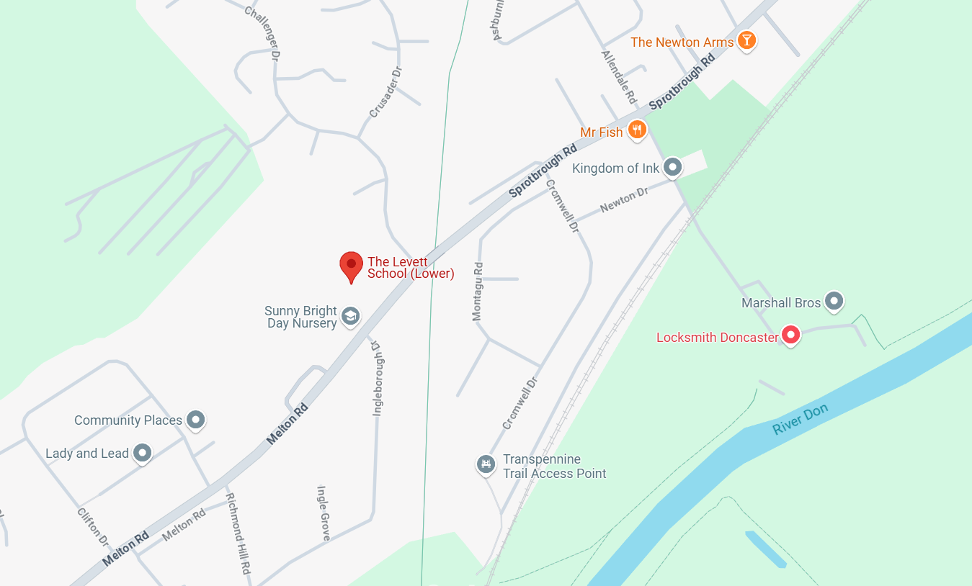

**Appendix 2.**

Parental Agreement (to be completed by the parent or carer)

* I have been informed of the absconding incident.
* I wish to make the following comments relating to the incident (optional):

____________________________________________________________________________________________________________________________________________________________________________________________________________________________________________________________________________________________________________________________________________________

I have read the Absconding procedure and policy.

I understand that it is always unacceptable for my child to leave the school site without permission, in line with safeguarding procedures. Repeated actions of this nature may lead the school to review the current educational offer, which could include limiting access to off-site visits and outdoor learning opportunities in order to ensure my child’s safety.

I understand that the following actions have been agreed in order to help my child be happy and safe in school.

|  |
| --- |
| Please state below actions: |

I know my child needs to keep to the school rules and not leave the school grounds without permission.

I understand that there are agreed actions for all parties involved. For my part, I will support this agreement by encouraging my child to comply.

Parent Signed: ____________ (Parent) Date: ____________