ADMISSIONS BOOKLET
2025 / 2026
POSITIVITY / DETERMINATION / REFLECTION / INTEGRITY

Year Group:
………………………………
UPN:
……………………………….
Registration Status:
……………………………….
Pupils name:
……………………………….
DOB:
……………………………….
Admission Date:
……………………………….


Class:
………………………………
Please note: If pupil attendance becomes a concern, this will trigger a review meeting to assess the suitability of your child’s placement at The Levett School.
Registration Details
Surname: | First Name: | Pupil’s Chosen Name:
Name of Mother: | Name of Father: | Pupil’s Chosen Name:

The following adults live with the child and act as parent (to include carers)
Name | Relationship | Parental Responsibility
 |  | ☐Yes ☐ No
 |  | ☐Yes ☐ No

The following adults have contact but do not live with the child
Name | Relationship | Parental Responsibility
 |  | ☐Yes ☐ No
 |  | ☐Yes ☐ No
Will your child require a taxi?
☐Yes ☐ No
Is your child a Free / Paid School Dinner?
☐ Free ☐ Paid
Ethnicity:
Traveller:
Religion:
Home Language:
Previous School:
Does your child have any special dietary requirements? ☐Yes ☐ No
If yes, please provide further information
……………………………………………………………………………
Pupil Sibling(s)
Name | DOB | School
Emergency Contact Details
Surname: | Forename: | Title:
Home Telephone: | Mobile Telephone:
Home Address:
Main Email Address: | Work Telephone:
Relationship to child: | Legal Responsibility: ☐ Yes ☐ No | Priority: ☐ 1 ☐ 2
Please give details of all persons who have legal responsibility for this child – Parent(s)/Guardian(s) and anyone else who can be contacted should an emergency arise when you are unavailable. You should use the contact priority number to indicate the preferred order in which contacts should be attempted in an emergency.
Surname: | Forename: | Title:
Home Telephone: | Mobile Telephone:
Home Address:
Main Email Address: | Work Telephone:
Relationship to child: | Legal Responsibility: ☐ Yes ☐ No | Priority: ☐ 1 ☐ 2
Medical Information
Name of Doctor: |  | Tel No:
Address:
Medical Conditions or Information
- Does your child suffer from fainting attacks or blackouts? | ☐ Yes ☐ No
- Does your child suffer from fits/epilepsy? | ☐ Yes ☐ No
- Does your child suffer from any allergy or hay fever? | ☐ Yes ☐ No
- a) Does your child have asthma? | ☐ Yes ☐ No
b) If yes, to above do they have a prescribed inhaler? ☐ Yes ☐ No
- Does your child suffer from diabetes? | ☐ Yes ☐ No
- Does your child suffer from ear trouble? | ☐ Yes ☐ No
- Does your child suffer from incontinence or bowel problems? | ☐ Yes ☐ No
- Are your children’s teeth in good health? | ☐ Yes ☐ No
- Is your child on medication for any of the above? | ☐ Yes ☐ No
If yes, please give details:

- Does your child suffer from any medical condition not mentioned above?
If yes, please give details:
- Is your child receiving medical treatment at the present time?
If yes, please give details:

- Has your child a diagnosis of ASD or associated?
- Has your child a diagnosis of ADHD?
14. Does your child have any food allergies
If yes, please give details:

Other relevant information:
Completed By: | Signed:
To be completed by staff only:
Pupil name: | Class:
Emergency Contact:
Food Allergies
Food allergies in children are common and can be life threatening if ignored, therefore it is imperative that we know if your child has been diagnosed with any food allergies.

Please identify if your child is allergic to any of the following:
☐ Cereals containing gluten and wheat – e.g. spelt, rye and barley
☐ Crustaceans, e.g. crab, prawn, lobster
☐ Molluscs e.g. mussels, oysters, squid, snails
☐ Fish
☐ Nuts, including almonds, hazelnuts, walnuts, cashews pecan, brazil and pistachio
☐ Peanuts
☐ Celery
☐ Eggs
☐ Soybeans
☐ Milk
☐ Mustard
☐ Sesame Seeds
☐ Suphur Dioxide and sulphite concentrations of more than 10mg/kg or 10mg/L in terms of total Sulphur dioxide
☐ Lupin
☐ Other
If you have stated yes to any of the above, please provide further details including medication and treatment plans.

............................................................................................................................................................................................................................................................................................................................................................................................................................................................

Other Agencies Involved
TEAM AROUND THE FAMILY
NAME: ………………………………………………
NUMBER: …………………………………………

CAMHS
NAME: ………………………………………………
NUMBER: …………………………………………

ANY OTHER AGENCIES
NAME: ………………………………………………
NUMBER: …………………………………………

SOCIAL WORKER
NAME: ………………………………………………
NUMBER: …………………………………………
PARENT & FAMILY SUPPORT WORKER
NAME: ………………………………………………
NUMBER: …………………………………………

EPIC
NAME: ………………………………………………
NUMBER: …………………………………………

Welfare
Has your child ever been subject to the following?
☐Looked after
☐Previously looked after
☐Special Guardianship order
☐Child arrangement order
☐Child in need

Has your child ever been a Young Carer? ☐ Yes ☐ No

Parental/Guardian Consent
HOME VISITS
There may be times where staff need to complete a visit to the family home. To ensure staff are safe when conducting visits, we would politely request you state below if there is a dog within the home.
There is a dog in the home - ☐ Yes ☐ No
If yes, please state the dog breed here - ……………………………………………………………………………………………………………………

LOCAL VISITS
As part of your child’s learning, or to develop community links, visits within the local area may be made from time to time. For any planned visit, we would aim to contact you to provide you with any additional information.

PHOTO CONSENT
I do / do not (delete as appropriate) consent to my child’s photo being used on the school’s website, social media and other promotional documentation.

SWIMMING (Years 1 – 6)
I do / do not (delete as appropriate) consent to my child’s accessing swimming lessons through The Levett School, in line with the National Curriculum expectations. (If consent is provided, please complete the adjacent local authority form)

EMERGENCY COLLECTION
In the event of an emergency, I agree to collect my child from school site within 60 minutes. In the event that I am unable to collect my child within 60 minutes, I will ensure that a trusted family member or family friend can collect my child on my behalf.
Emergency events include, but are not limited to:
- Refusal of transport
- Unsafe behaviours that result in refusal to transport from driver
- Sudden school closure due to health & safety emergency

Please sign below to confirm the above information has been shared with you.

Parent / Carer Name:
Signed:
Date:

GENERATIVE AI USE
I do / do not (delete as appropriate) consent to my child’s work being used in AI platforms for educational purposes, such as learning support or marking.

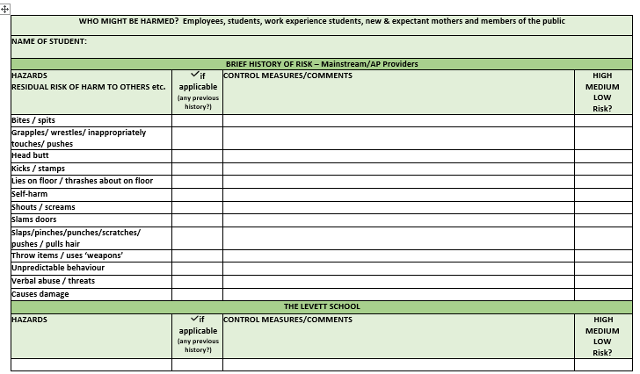
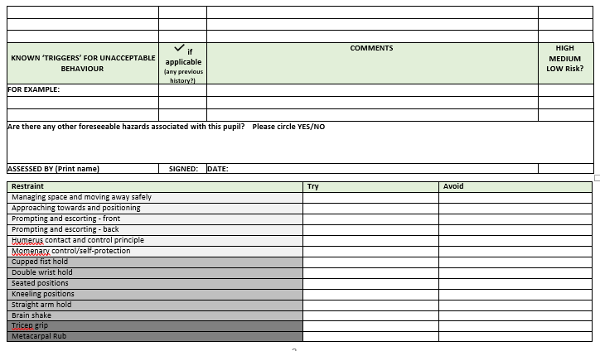
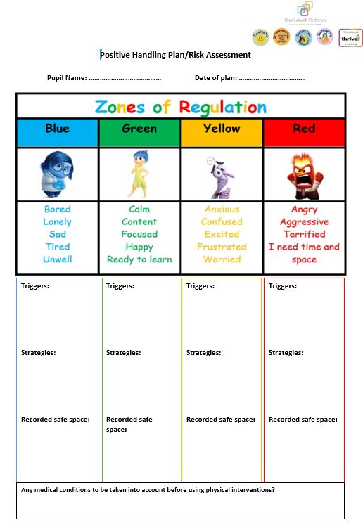

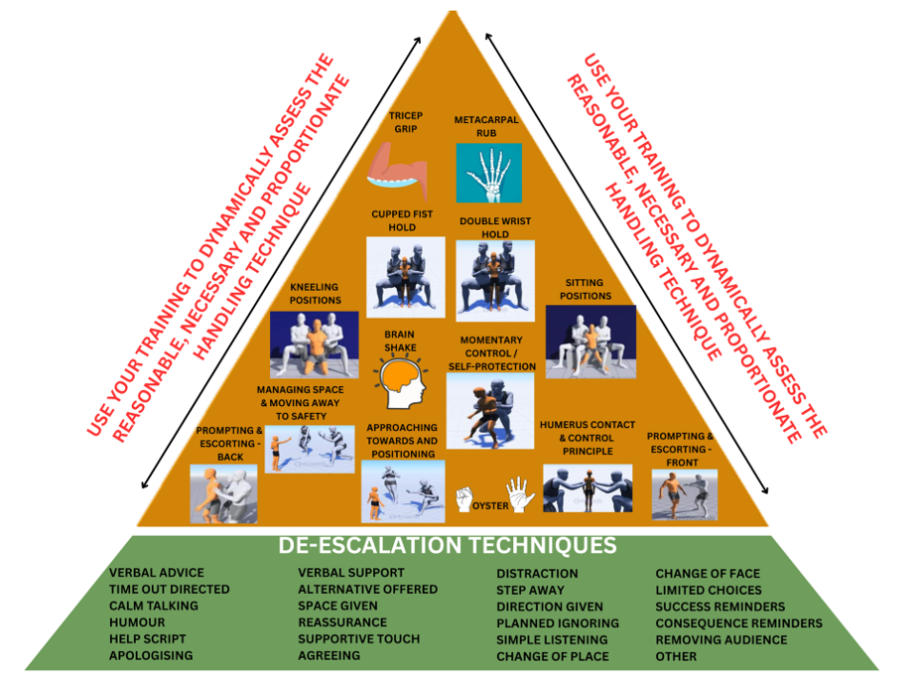


EDUCATION SWIMMING – PARENT/CARER CONSENT FORM

Name ……………………………………………………. School……………………………………………………………
Date of Birth …………………………………………. Class …………………………………………………………....
Address ………………………………………………………………………………………………………………………………………………………
Tel No …………………………………………………………...
As part of your child’s education he/she will be undertaking swimming lessons this ear. It is important that the swimming teacher has the following information concerning your child:
 | Yes | No
Does your child suffer from any of the following:
Anxiety from water
ADHD
Asthma (please bring inhaler to every swimming lesson)
Autism
Behaviour
Cerebral Palsy
Diabetes
Down Syndrome
Epilepsy
Grommets (recommend wearing a swimming cap & ear plugs)
Hearing impairment
Visual impairment
Does your child have any other medical conditions? Give details:

Does your child take medication on a regular basis? Give details:

Please give details of any past or present injuries e.g. fractures

Swimming Ability:
Non-swimmer | 5m | Width | Length | 2 lengths | Any other Awards (please specify)
Earrings and any other form of jewellery or watches must be removed prior to the swimming lesson. Plasters covering newly pierced ears must be removed together with the earrings before a pupil will be allowed to swim.
Goggles are not necessary within short curriculum swimming lessons or for single, short races in school galas unless a pupil has particularly sensitive eyes. Goggles will only be allowed in exceptional circumstances in school swimming lessons, when chemicals in the water may adversely affect eyes. In these rare instances where the use of goggles may be allowed the adult responsible for the group will have the prerogative to require the pupil to remove them for reasons of safety if the pupil constantly adjusts or removes and replaces the goggles. If it is medically necessary for your child to wear goggles a letter must be written to school stating that your child has particular needs to warrant the use of goggles.
I have read and understood the information included on this form.
Signature of Parent/Carer …………………………………………………………… Date ……………………………………….
Please note your child will not be allowed to swim unless this form is completed. Please return to your child’s school
ICT Acceptable use agreement

At The Levett School, pupils are expected to:

- Only use ICT on the school premises for studying purposes.
- Only log on to the computer and internet when an adult is present.
- Use the class or school e-mail address when sending or receiving emails.
- Only open email attachments from people known to them or people who the teachers have approved.
- Make sure ICT communication with other pupils and adults is polite and responsible.
- Be responsible for their behavior while using ICT.
- Inform their class teacher of anything they see online which makes them feel uncomfortable.
- Understand that their use of ICT can be checked and that parents/carers will be contacted if a member of school staff is concerned about a pupil’s e-safety.
- Be careful when using computer equipment and treat it with respect.
- Abide by the rules regarding bringing personal devices into school.
- Seek the advice of a teacher before downloading material.

Pupils will not:

- Try to bypass the internet settings and filtering system.
- Share passwords.
- Delete or open other people’s files and documents.
- Use other people’s accounts.
- Send any content which is unpleasant. If something like this is found, such as inappropriate images or the use of offensive language, pupils will report it to their teacher.
- Share details of their name, phone number or address.
- Meet someone they have contacted online, unless it is part of a school project and/or a responsible adult is present.
- Upload images, sound, video or text content that could upset pupils, staff and others.
- Try to install software onto the school network.

Parents will:

- Support and uphold the school’s rules regarding the use of school ICT systems.
- Act in accordance with the school’s policy when using the internet in relation to the school, its employees and pupils.
- Only store and use images of pupils for school purposes, acting in line with the school’s ICT policy.

Please complete the below information to confirm you have read and accept the above agreement.
Pupil Name:
Parent / Carer Name:
Signed:
Date:

PRIVACY NOTICE

The Council is committed to meeting its data protection obligations and handling your information securely. You should make sure you read and understand this notice before submitting your information to us.

Privacy Notice – General Data Protection Regulation (GDPR)
The Levett School is a ‘Data Controller’ as defined by Article 4 (7) of GDPR. This means that we determine the purpose for which, and in the manner in which, your personal data is processed. We have a responsibility to you and your personal data and will only collect and use this in ways which are compliant with data protection legislation.
The school has appointed the Local Authority to be its Data Protection Officer (DPO). The role of the DPO is to ensure that the school is compliant with GDPR and to oversee data protection procedures. The contact details are:
Data Protection Officer – Schools & Education
Phone 01302 737978
Address Floor Two, Civic Office, Waterdale, Doncaster, DN1 3BU
Email schooldataprotectionofficer@doncaster.gov.uk
Website www.doncaster.gov.uk

This information includes your contact details, national curriculum assessment results, attendance information and personal characteristics such as your ethnic group, special educational needs and any relevant medical information. If you are enrolling for post 14 qualifications, we will be provided with your unique learner number by the Learning Records Service and may obtain from them details of any learning or qualifications you have undertaken.

The full Privacy notice can be found on the school website.
http://levett.doncaster.sch.uk/about-us/policies/
If you want to see a copy of the information, we hold and share about you then please contact the School Business Manager in the first instance.

Complaints
If you are unhappy with the way in which your information has been handled you should contact the Council’s Data Protection Officer so that we can try and put things right.
Alternatively, and if we have been unable to resolve your complaint, you can also refer the matter to the Information Commissioner’s Office (ICO). The ICO is the UK's independent body set up to uphold information rights, and they can investigate and adjudicate on any data protection related concerns you raise with them. They can be contacted via the methods below:

Website: www.ico.org.uk
Telephone: 0303 123 1113
Post: Information Commissioner’s Office
Wycliffe House
Water Lane
Wilmslow
Cheshire
SK9 5AF

Key School Staff
Office Manager
Miss Fiona Mooney
Admin
Mrs Bev Evans, Ms Cherie Gill,
Mrs Shelly Evans
School Business Manager
Ms Beverley Jones
Assistant Headteacher
Miss Emma Place
Safeguarding Director
Miss Hayley Johnston
Building Manager/Caretaker
Mr Neil Dyson & Mr L Field
Safeguarding Officer
Miss Rachel Kelly &
Mrs Karen Short
Teachers
Miss Sara Rook, Mrs Lydia Shipley, Mrs Helen Megaw,
Mrs Amanda Brown & Miss Shannon Robertson
HLTA
Mr Alex Brown
Learning Mentor
Mrs Bev Craswell
Cover Supervisor
Mrs Nadya Zbiec
Teaching Assistants
Miss Xena Needham, Miss Amanda Jones, Mrs Amanda Goddard, Miss Ashleigh Camm, Miss Cody Marriott,
Ms Stacey Holmes, Mrs Kathryn Stanley, Mr Paul Clarke, Miss Nicola Robinson & Miss Scarlett Hall
Head of School
Miss Hannah Buchanan

School Uniform Expectations

SCHOOL UNIFORM

- Black shoes
- Black trousers/jogging bottoms or skirt.
- Levett School t- shirt & sweatshirt
(One of each will be given to you on your child’s first day. Should you require any more you can purchase them from school at a cost of: £3.50 for t-shirts and £7 for sweatshirts).

PE KIT

Your child needs to come to school in PE kit on the day they have PE.
- Any sportswear
- Trainers
Please note: Clothes should not contain any obvious branding / logos, other than The Levett School logo.

JEWELLERY

For the protection of personal safety, the wearing of jewellery is not permitted in school. This includes but is not limited to: Rings, necklaces, bracelets and earrings
- The wearing of jewellery can result in tearing or piercing of flesh;
- There is a potential for injury to the wearer due to inadvertent contact of jewellery with other people, clothing etc;
- Injury could occur due to contact with jewellery worn by another person

Should your child be required to wear jewellery for religious or medical reasons, parents/carers must apply in writing to the Headteacher.

The Levett School (Lower)
Melton Road
Sprotbrough
Doncaster DN5 7SB
Tel: 01302 390761
Email: admin@levett.doncaster.sch.uk

Agreed Contract

TRANSITION SCHOOL WILL: SIGNED: DATED:

- Support the admission procedures for…………………………………………………. and attend the admission meeting
- Determine agreed outcomes and success criteria
- Identify the behaviours to be tracked during placement
- Provide present and previous academic levels
- Provide the expectations for the end of the school year and key stage (based on their own assessment and tracking)
- Provide The Levett School with any other relevant documentation
- Maintain dual roll status until it is agreed for this to be changed (if applicable)
- Keep in regular contact with The Levett School as to progress made
- Attend all review meetings
- Host and lead TAC meetings during Dual Rolled Status
- Take responsibility for SEND documentation and referrals with support from The Levett School
- Due to locality, take responsibility for safe and well visits when attendance concerns present
- Call immediate SEN interim review for pupil with EHCP if required
- Provide additional support during any transition back to the school

THE LEVETT SCHOOL WILL: SIGNED: DATED:

- Admit.................................. following admission procedures
- Arrange transport if required
- Agree outcomes and success criteria
- Agree the identified behaviours to be tracked during placement
- Agree and complete baseline assessments
- Assess and track progress against agreed identified behaviours, academic expectations, outcomes and success criteria
- Hold Pupil Review meetings to discuss progress towards transition
- Support the transition school to complete and submit paperwork for statutory assessed requests where applicable
- Host SEN interim reviews where applicable
- Identify appropriate outside additional support or intervention
- Offer support to parents/carers during placement
- Update/Return Pupil to Panel to discuss transition when appropriate
Booked Review Meetings:
(2 visits for 6 week placement, 4 for 12)
1. ………………………………………
2. ………………………………………
3. ………………………………………
4. ………………………………………
Success Criteria:
………………………………………………………………………………………………………………………………………………………………………………………………………………………………………………………………………………………………………………………………

Agreed Outcomes:
………………………………………………………………………………………………………………………………………………………………………………………………………………………………………………………………………………………………………………………………

PARENT/CARERS WILL: SIGNED: DATED:
- Support all admission procedures
- Attend all pupil reviews, SEND reviews and TAC meetings if appropriate
- Provide any relevant information to the school whenever appropriate
- Maintain links with school by phone/email
- Agree to the school behaviour policy
- Support school with uniform and code of conduct
- Ensure their child attends school regularly and in a timely manner
- Book medical/dental appointments outside of school hours wherever possible and provide evidence for appointments that require your child to miss time at school
- Attend school events where appropriate to support their child

ATTENDANCE
PEERS / CLASSROOM
WHATS WORKING WELL / WHAT NEEDS TO IMPROVE
STRENGTHS
DIFFICULTIES
ASSESSMENT
REQUEST FOR OTHER PROFESSIONALS
TRANSITION
​REVIEW MEETING

DATE ……/……/……… TIME ………………

MEETING MEMBERS

