**The Levett School**

**Assessment Policy**

|  |  |
| --- | --- |
| ***Policy agreed by Management Committee on:*** | 01.07.2025 |
| ***Review date for Management Committee:*** | 01.07.2026 |
| ***Allocated Group/Person to Review:*** | Lydia Shipley |
| ***Agreed frequency of Review, by allocated person:*** | Every Year |
| ***Last Review date:*** | 20.05.2025 |

**Melton Road, Sprotbrough, Doncaster, DN5 7SB**

**Assessment Policy**

1. **Rationale and Context**

The Levett Schools aim is to approach assessment not as a process for the collection and collation of data, but as a tool for supporting the ambitions of our pupils and for driving them on to fulfil their goals and beyond. For assessment to be truly effective this requires any dialogue, decision or data produced by the process to be consistent, accurate and rigorously scrutinised.

1. **Fundamentals**

* Teachers will plan learning that accurately reflects the personalised needs of each pupil; give each pupil the equal opportunity of their entitlement to the National Curriculum, developing their social, intellectual, moral, emotional, spiritual and physical skills by assessing their progress in these areas.
* Use records to inform and enable successful reintegration of pupils into mainstream or alternative

provision providers.

* Learning objectives will be shared with pupils in every lesson.
* Success criteria will be referred to in every lesson to help the teacher and pupil to make judgements about the quality of pupil learning.
* Assessment for learning will have clear opportunities and be utilised in every lesson.
* Pupils will play an active part in the formative assessment of their own learning by RAG rating their own learning objective to exit the lesson.
* Pupils know how they are being assessed, in order to recognise the standards to aim for and to understand what they need to do next to improve.
* All learning is marked in accordance with the live marking policy.
* End of unit learning / assessments will be formally marked.
* Formative assessment will take place on a half-termly basis.
* Individual summative assessments are recorded on OTrack and/or KS3 grid tracker three times per academic year.
* Summative data needs to be entered onto OTrack and KS3 grid tracker before the last week of half term by all teaching staff.

1. **Planning for Assessment**

**3.1 New Pupils**

A base-line assessment will be conducted within the first two weeks of being given a Levett School placement, using a combination of: observation, classwork, oral and written summative testing and communication with the previous education provider. Academic, social, emotional and behaviour assessments are carried out to establish personalised targets.

**3.2 Curriculum Planning**

We use our school's curriculum overview to guide our teaching. In this overview, we set out the outline of what is to be taught to each year group, schemes of work are used to give the detail for each subject. Medium Term plans are written that show the objectives the pupils will be working towards and the personalised activities to meet those objectives. We base these upon the teacher's detailed knowledge of each pupil. We strive to ensure that all tasks set are appropriate to each pupil’s ability.

1. **Formative Assessment (Assessment for Learning)**

This involves the use of assessment in the classroom to raise pupil achievement. It is based on the idea that pupils will improve most if they understand the aim of their learning, where they are in relation to this aim, and how they can achieve this aim. (i.e. to close the gap in their knowledge).

We record how each pupil has accessed the learning objective and whether they have partially met the outcome (B - beginning), working towards the outcome (D - developing) met the outcome (AT-ARE) or exceeded the outcome (GD – Greater Depth), so that we can take the needs of these pupils into account when planning for the next lesson.

A grading system is in place which indicates how well the pupils have understood that particular unit of work. The goal is for pupils to reach their termly targets based on the five stages of progress we want our pupils to meet a year. Our ambition is to get as many pupils to reach their year group ‘AT’ threshold and beyond. We expect pupils to make one stage of progress each half term.

**4.1 Key Stage One and Two**

For pupils working at Primary level a grading system is in place which indicates how well the pupils have understood that particular unit of work based on their Age-Related Expectations (ARE). The goal is to get as many pupils to reach the ‘AT’ threshold and beyond for the year group they are working within. However, at The Levett School we recognise that many pupils are working below their Age-Related Expectations and so we set end of year target grades based on their baseline assessment taken on entry to The Levett School. We expect pupils to make one stage of progress each half term.

The scale for primary is:

|  |  |  |  |  |  |
| --- | --- | --- | --- | --- | --- |
| Working **below** end of year expectations | | Working **towards** end of year expectations | | Working **at** end of year expectations | Working **above** end of year expectations |
| **Beginning** | **Beginning +** | **Developing** | **Developing +** | **At** | **Going Deeper** |
| **B** | **B+** | **D** | **D+** | **AT** | **GD** |
| *Has been taught but pupil does not understand it.* | *Showing some understanding of skills, concepts and knowledge in a unit of work/ topic.* | *Showing a broader understanding and some application of skills, concepts and knowledge of a unit/ topic.* | | *Has consistent understanding and application of skills, concepts and knowledge of work/ unit.* | *Has demonstrated application and understanding of skills, concepts and knowledge in contexts beyond those taught in the unit/ topic* |
| Beginning to grasp some of the main ideas and skills in a unit/ topic.  Often needs significant support from the teacher or TA’s to understand. | | Grasped some of the main ideas and skills in a unit/ topic but may require support or more repetition of objectives to secure their understanding. | | Has a **secure** understanding of the main concepts and skills when applied in familiar concepts | Pupils demonstrate mastery of skills.  They can apply learning out of context. |

**4.2 Transition from Key Stage Two to Key Stage Three**

For those KS2 pupils who are moving into Year 7, or who begin at The Levett School in a secondary year group transfer to the KS3 formative grid assessment system. When grading a pupil, if their progress is significantly low they will remain on the KS2 system so that some intense intervention can be planned for and delivered. These pupils may join the nurture class group.

When grading a pupil, SATs data and end of Y6 assessment data will determine which GCSE grade they are working towards. Over the year it is expected they will progress through 5 steps: B, B+, D, D+ and finally AT. Some pupils may excel and achieve the GD step but this is not essential.

**4.3 Key Stage Three**

Each subject has a grid with grades 1-9 that link to predicted GCSE grades. Next to each grade is a description of what they should be able to do. This is then tiered for each year group.

For secondary the scale is:

|  |  |  |  |
| --- | --- | --- | --- |
| **Beginning** | **Developing** | **AT (**Secure) | **Going Deeper (**Mastered**)** |
| **B and B+** | **D and D+** | **AT** | **GD** |
| The pupil is starting to develop the concepts, methods, knowledge and skills covered in a topic/ unit of work. | The pupil is more familiar with concepts, methods and skills covered and can is beginning to apply these skills. | The pupils secure in and has consistent understanding and application of the concepts, methods and skills covered. | The pupil is at ease with the concepts, methods and skills covered and has demonstrated application and understanding beyond those taught in the unit/ topic. |
| * In English, their responses are simple. * In Maths, they attempt standard computational questions. * In Science, pupils can use basic terminology to identify some scientific concepts | * In English, their responses show more detail and development. * In Maths, they attempt standard computational questions with some success. * In Science, pupils can describe a range of scientific concepts accurately. | * In English, their responses are clear and relevant to the question. * In Maths, they successfully complete standard computational questions and begin to apply their knowledge. * In Science, pupils can describe and explain a range of scientific concepts | * In English, their responses are perceptive and detailed. * In Maths, they successfully apply their knowledge to multistep and unconventional problems. * In Science, pupils are able to use complex terminology to describe and explain a wide range of scientific concepts and are able to apply their understanding to unfamiliar situations. |

The goal is for pupils to reach their termly targets based on the five stages of progress we want our pupils to meet a year. Our ambition is to get as many pupils to reach their year group ‘AT’ threshold and beyond. We expect pupils to make one stage of progress each half term.

*It is important to note that assessments gradually become more challenging as pupils move from year to year, so pupils can continue to achieve ‘At’ for example and be making expected progress.*

**4.4 Formative Pupil Booster Plans**

The aim of the personalised pupil booster plans allows The Levett School to strive to close the progress gap more efficiently, offering a mid-point review between summative data collection points, reviewing progress half termly so that pupil progress is at its best. The formative collection data identifies target pupils for all different interventions. Taking the profile of the pupil into account, highlighting any SEMH/SEN information which could have impacted on progress, all child facing staff analyse if pupils are on track to meet their termly targets. Following this, implementation strategies are suggested in order to support that pupil for the following half term. The outcome of the booster plans is to positively impact pupil progress. These plans are used as a talking tool in pupil progress meetings.

* **Summative Assessment (Assessment of Learning)**

This involves judging pupils' performance against national standards. Teachers make these judgements in at the end of each half term. Summative assessments:

* Provide a summary judgement about what has been learned by each pupil at a specific point in time.
* Show what pupils can achieve without support.
* Inform any subsequent intervention activities.

Each term pupils will be given a grade in the following subjects:

**Flight Paths**

Flight paths for core subjects are created so pupil progress journeys can be tracked and a 360 Flight Plan is created to establish an accurate pupil profile. These are used in pupil progress meetings and shared with all relevant stakeholders.

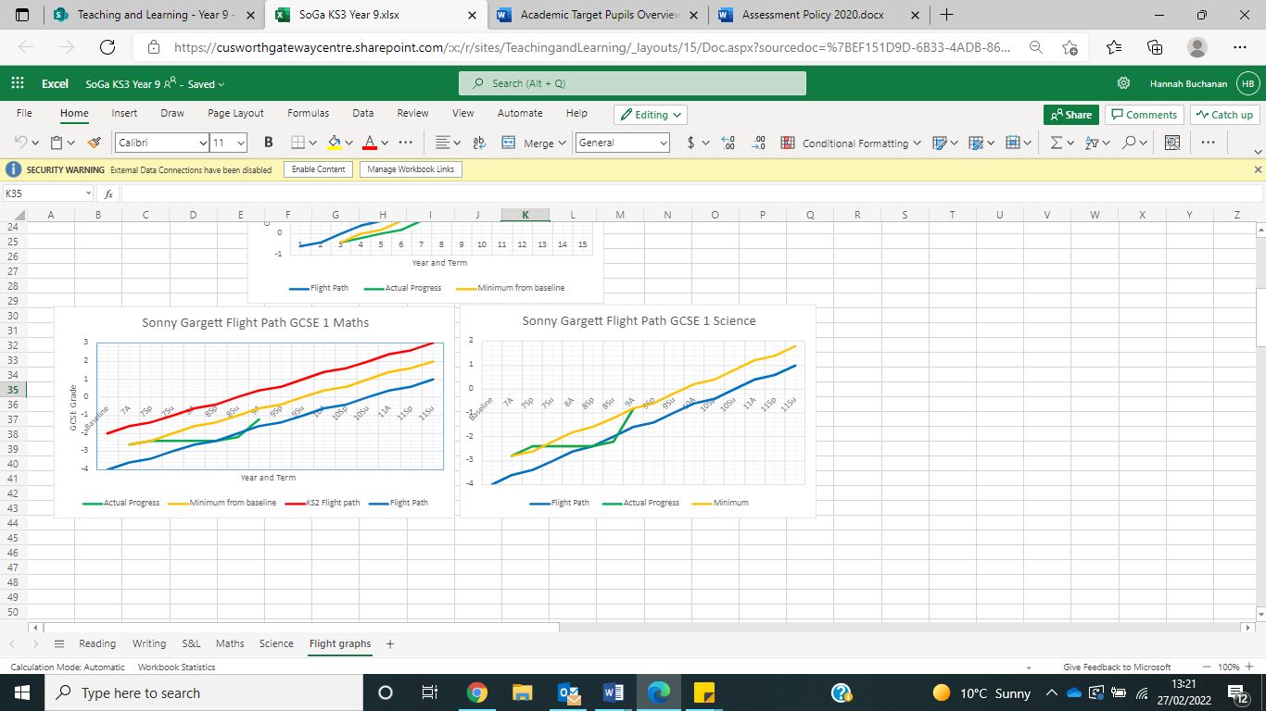

|  |  |
| --- | --- |
| **Core Subjects** | Maths  Literacy  Speaking & Listening  Science  Reading |
| **Foundation Subjects** | Computing  Art & Design  Design and Technology  Geography  History  PE  Design Technology  Languages and Music (KS2 only)  PSHCE and RE ( KS3 only) |

* **Subject Specific Unit Assessment and Recording**

We recognise various methods of assessing pupil’s learning. The type of assessment that we make varies from subject to subject.

|  |  |  |
| --- | --- | --- |
| **Subjects** | **Key Stage One and Two** | **Key Stage Three** |
| Maths | White Rose Maths (WRM) pre and post topic/ unit assessments.  Use of previous SATs questions to apply skills and knowledge.  IXL termly diagnostics | White Rose Maths (WRM) pre and post topic/ unit assessments.  RISC questions.  GCSE Module Tests to inform intervention planning and delivery.  IXL termly diagnostics |
| Literacy | Independent piece of writing at the end of the unit.  IXL termly diagnostics | Independent piece of writing at the end of the unit.  IXL termly diagnostics |
| Reading | IXL termly diagnostics  Little Wandle Phonics | IXL termly diagnostics  Little Wandle Phonics |
| Science | Pre and post brainstorm for pupil knowledge and skills. | Pre and post brainstorm for pupil knowledge and skills.  GCSE Module Tests between units. |
| Foundation Subjects | *Currently being developed.* | *Currently being developed.* |

*Please see* ***subject policies*** *for more details on the assessment methods and units.*

* **Roles & Responsibilities**

**All staff** with a defined teaching role will be responsible for following the policy and providing data as per the expectations. They always share the lesson's learning objective with the pupils as the lesson begins. They also indicate the way in which the activity is linked to the learning objective, and the criteria against which the work will be judged. These are taken from OTrack or KS3 Grid Trackers. Teaching staff ask well phrased questions and analyse pupils' responses to find out what they know, understand and can do, and to reveal their misconceptions.

**Teachers and Teaching Assistants** are responsible for carrying out summative and formative assessments with individual pupils, small groups and whole classes, depending on the context teaching staff are responsible for entering summative data on a termly basis onto OTrack and/or the KS3 Grade Trackers for progress. This is due the week before term ends, to aid reporting to the Senior Leadership Team for quality assurance so that accurate reports are shared with parents. Staff will be held accountable for this data being available on the appropriate spreadsheets.

**The Assistant Headteacher of Teaching and Learning** will be responsible for monitoring use of the policy and disseminate it effectively to all staff and stakeholders. They are responsible for monitoring it’s use on a day-to-day basis, and ensure training is effective and allows all staff equitable access to the policy. They are responsible for quality assuring this data on a daily basis and leading on pupil progress meetings with teaching staff on a half termly basis. This information then produces reports which are fed back to the Head of School and Executive Head in regards to attainment and trends.

**The Senior Leadership Team** is responsible for monitoring use of the policy and quality assure the data presented from teachers is accurate and shows sufficient stages of progress. They support in the pupil progress meetings with teaching staff to offer a streamlined approach to the quality assurance process. Pupil progress is an itemised agenda on leadership meetings to constantly review what is happening in school, as well as identifying the best way to address any concerns and celebrate successes.

* **Pupil Progress Meetings**

Pupil progress meetings are held three times a year after the summative collection data. These meetings are led by the senior leadership team in dialogue with the class teachers and subject leaders in regards to the progress made that term. This includes all areas of progress in terms of academic, social, emotional and behavioural. The meetings provide a rigorous and robust forum using the 360 flight paths to answer questions posed by the data within pupil tracking and enable us to move tracking off the page into actions for learning. It also provides an opportunity to demonstrate and celebrate success.

* **Feedback to pupils**

We believe that feedback to pupils is very important, as it tells them how well they have done, and what they need to do next in order to improve their work. All pupilswill be shared their outcomes as part of an ongoing dialogue about their learning progress; this happens daily in each lesson, it is also facilitated through learning conferences held each term where pupils and teachers share their 360 flight path and discuss academic and behavioural progress and jointly set targets. The dialogue encourages pupils to make improvements and strive to be the best versions of themselves. Pupils can earn points towards these targets in the reward system.

Full details about this can be found in the Live Marking Policy and Reward Policy.

* **Reporting to Parents and Carers**

We have a range of strategies that keep parents fully informed of their child's progress. We encourage parents to contact the school if they have concerns about any aspect of their child's work. Class teams make regular phone calls home to share information.

They are invited to parents evening meetings three times a year to discuss with their child’s teacher, at length, the progress made academically, socially, emotionally and behaviourally. Targets and outcomes are shared, provisions are updated and next steps are put into place.

During the summer term, we give all parents a written report of their child's progress, efforts and achievements during the year. In this report, we also identify target areas for the next school year in each subject. In the Autumn and Spring terms a progress report will also be sent home showing progress made towards their end of year targets. In reports for pupils in Year 6, we also provide details of the levels achieved in the National Curriculum tests.

* **Reporting to External Agencies and Mainstream Schools**

We have a range of strategies that keep pupil dual registered schools or agencies fully informed of their pupil’s progress. We encourage schools/agencies to contact the school if they have concerns about any aspect of pupil progress. They are also invited to visit the pupil on a regular basis (half termly) to keep an accurate and up to date account of pupil’s progress, allowing for the communication and dialogue between schools to be purposeful.

They are invited to join parents in the parents evening meetings three times a year to discuss with the pupil’s class teacher, at length, the progress made academically, socially, emotionally and behaviourally. Targets and outcomes are shared, provisions are updated and next steps are put into place.

During the summer term, they are sent a copy of the pupil’s progress, efforts and achievements during the year. In this report, we also identify target areas for the next school year in each subject. In the Autumn and Spring terms a progress report will also be sent home showing progress made towards their end of year targets.

1. **Inclusion and Assessment for Learning**

Our School aims to be an inclusive School. We actively seek to remove the barriers to learning and participation that can hinder or exclude individual pupils, or groups of pupils.

We achieve educational inclusion by continually reviewing what we do, by monitoring data, and through asking ourselves questions about the performance of these individuals and groups of pupils. In this way, we make judgements about how successful we are being at promoting racial and gender equality, and including pupils with disabilities or special educational needs.

1. **Quality Assurance and Moderation of Standards**

All teachers study examples of pupil’s work within school. They use the national exemplification materials to make judgements about the levels of the pupil’s work. All our teachers discuss these levels, so that they have a common understanding of the expectations in each subject. By doing this, we ensure that we make consistent judgements about standards in the school.