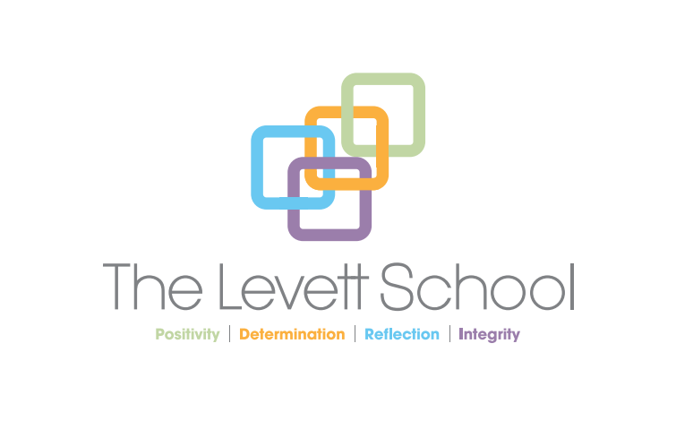
The Levett School

Special Educational Needs and Disabilities Policy – Child Friendly
Policy agreed by Management Committee on:
Review date for Management Committee: | June 2026
Allocated Group/Person to Review: | Emma Place
Agreed frequency of Review, by allocated person: | Every Year
Last Review date: | March 2026

Melton Road, Sprotbrough, Doncaster, DN5 7SB

Contents:

The school’s promise
- What is SEND?
- Things we look out for
- How we will help pupils with SEND
- When we will talk to pupils and their parents
- Help with learning
- Keeping happy and healthy
- Privacy
- Policy review

🌟 The Levett School – Pupil-Friendly SEND Policy 🌟

💖 Our Promise to You
At Levett School, we care about all of you. We want you to feel
happy, safe and healthy.

This guide shows you:
- How we support you if you have SEND
- Who you can talk to if you have a problem

- How we can work together to help you learn and enjoy school

🧩 What is SEND?
SEND means Special Educational Needs and Disabilities.
It describes when a pupil:
- Finds learning harder than others
- Needs extra help from teachers or staff
- Has a health problem or disability making school tasks harder
Everyone with SEND is unique. You might:
- Find it hard to understand words or talk clearly
- Feel worried in situations that others find easy
- Struggle to understand feelings – yours or others’
- Have physical or sensory challenges like hearing, seeing, or holding things
Remember: SEND is what makes you special and amazing.

👀 Things We Look Out For

Teachers and staff are trained to spot signs of SEND. Signs might include:
- Finding learning harder than friends
- Needing extra help to join in activities
If we notice this, we will assess your needs and give support quickly.


🛠️ How We Help
We support pupils with SEND by:
- Making plans to track the help you get
- Talking to your parents/carers to make sure support is right
- Setting targets to help you do your best
- Knowing your strengths and challenges
Support may happen:
- In the classroom
- At break or lunchtime
- In small groups or 1:1 sessions
Sometimes others may get different help. That’s fair, because everyone’s needs are different.

We will ask you how you feel about your support. This is called “Voice of the Child”. Your thoughts help us improve support.

📄 Education, Health, and Care Plans (EHCPs)
Some pupils may need an EHCP. It tells us:
- Your difficulties
- The help you need
- Your thoughts and wishes
You will help make the plan, along with your parents/carers. You will also have a member of staff to support and guide you.

📞 Talking to Your Parents or Carers

- We may phone home daily to share how your day went
- Your parents/carers can call us if you are having a tricky day
- Working together helps you get the right support at school
and home


📚 Help with Learning
We make sure your SEND does not stop you from doing your best.
- Every lesson is designed so everyone can join in
- Teachers and assistants are trained to support you in the best way
- Your support plan shows:
  - Your strengths
  - Your challenges
  - Your interests and goals
- You will set targets with your teacher and check them regularly
- If you reach your targets, new ones will be set
- We will involve your mainstream school and parents/carers in progress meetings


😊 Keeping You Happy and Healthy
We want all pupils to be happy and healthy.
- Talk to any adult in school about your schoolwork or feelings
- Pupils with SEND are offered mentor time to discuss emotions
- Support may include:
  - 1:1 support with a teaching assistant
  - Working in a quieter space
  - Using special tools or equipment

🔒 Privacy

Your information is private.
- Staff will only share it if needed by law
- Only people who need to know about your SEND will be told

📝 Policy Review
- This policy is reviewed every year by the SENCO
- Updates make sure our support is the best it can be for all pupils

