**The Levett School**

**Special Educational Needs and Disabilities Policy – Child Friendly**

|  |  |
| --- | --- |
| ***Policy agreed by Governors on:*** | 01.07.2025 |
| ***Review date for Governors:*** | 01.07.2026 |
| ***Allocated Group/Person to Review:*** | Emma Place |
| ***Agreed frequency of Review, by allocated person:*** | Every Year |
| ***Last Review date:*** | May 2025 |

**Melton Road, Sprotbrough, Doncaster, DN5 7SB**



**Contents:**

The school’s promise

1. What is SEND?
2. Things we look out for
3. How we will help pupils with SEND
4. When we will talk to pupils and their parents
5. Help with learning
6. Keeping happy and healthy
7. Privacy
8. Policy review

**The school’s promise**

At Levett School we care about all of you - our pupils and because we care, we want you to feel happy and healthy at school. To make sure this happens, we have created this policy which tells you how we will offer you support, who you can talk to if you have problems and how we can work together to help you learn and enjoy school.

**What is SEND?**

SEND stands for **Special Educational Needs and Disabilities**.

It is a word used in schools to describe a pupil who struggles with learning and sometimes needs extra help from teachers and classroom staff.

It is also used to describe a pupil who has a problem with their health or who has a disability which makes it difficult for them to learn or use things in the classroom that other people may find easy to use.

If a pupil has SEND, they may find their day-to-day tasks a challenge.

Just like with everyone, people with SEND are unique and their needs and disabilities will differ. Some people may struggle with understanding what is being said to them, speaking clearly and talking with others.

Other people may struggle with understanding how themselves and others feel, or they may get very worried in situations which seem easy for others to deal with, such as going into the dining room or doing PE.

People with SEND may also struggle with their senses or physical needs, for example, they may not hear very well or might not be able to hold objects well.

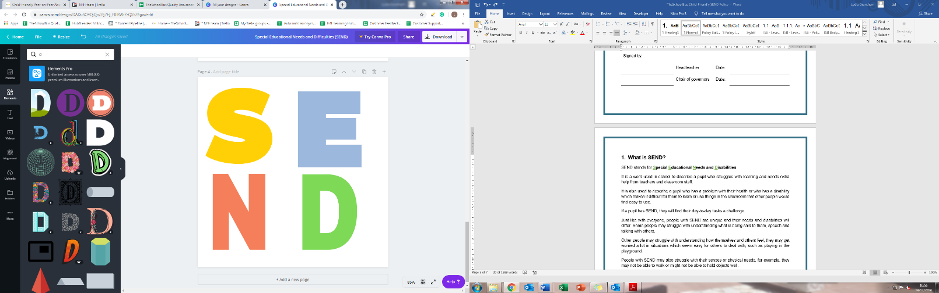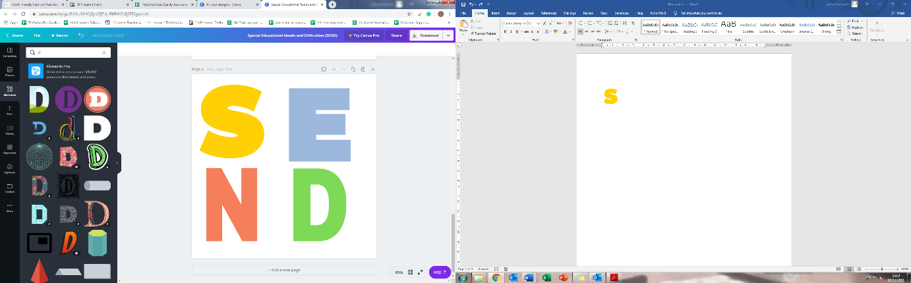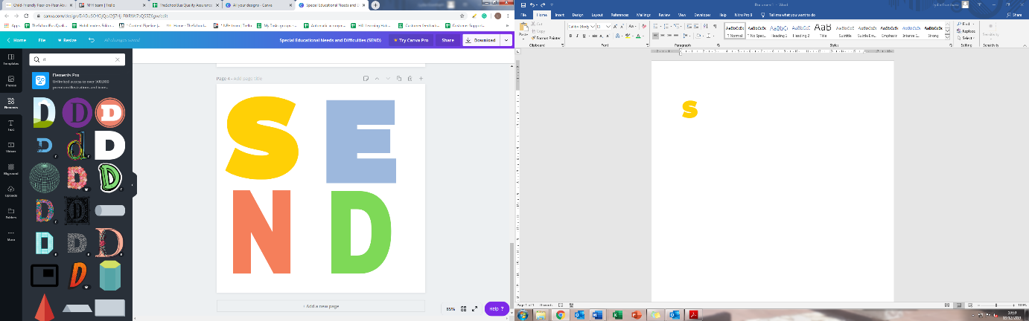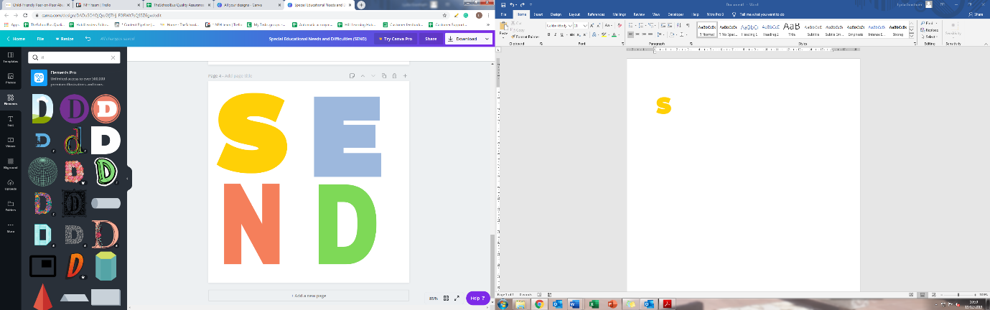

There are many different ways a pupil can struggle, but what is important to remember is that they should not be treated unfairly or made to feel alone or unwanted because of their SEND.

**Remember, having SEND is not a bad thing. SEND is what makes you unique and amazing. You should never feel embarrassed about having SEND and no one else should ever try to make you feel bad about it either.**

**Things we look out for**

If you have SEND, you might have already been told so by an adult, for example, your parents or carers, a doctor or teacher. It is the school’s job to make sure that, if you have SEND, you are looked after and can still join in activities. That is why teachers and other staff will be trained to spot signs of SEND and give help where needed. Teachers will also try to change the lesson for you to make sure you can always be included and achieve.

If a pupil struggles a lot more than their friends to learn new things, they may have SEND. Pupils who might have SEND will be assessed by a grown-up to make sure they get the right help. The school will try and help pupils with SEND as soon as possible.

**How we will help pupils with SEND**

Teachers are here to help all pupils but there are things they will do to help pupils with SEND. These include:

Making plans and keeping track of the help given to pupils with SEND

Talking to the parents or carers of pupils with SEND to make sure the help in place is suitable

Setting challenging targets for pupils with SEND to help them achieve their best

Knowing the needs of all pupils and the special help that is in place to help pupils with SEND

Other members of staff in school will work closely with your parents or carers and other grown-ups to help you make the most of your time in school and enjoy as many new things as possible.

Help will be given in the classroom, at break time and lunchtime, and will be different for each pupil. Sometimes some children say “It’s not fair” when one child gets treated differently to others, but treating people differently to help them is very fair; it would be very unfair if we didn’t do things differently to help those that need it.

Levett staff will always talk to you to see if you like the extra help you are getting and whether there is anything you would like to change – it is important that you are honest when you have these chats and make sure someone knows how you really feel. We call this “Voice of the Child” and it is very useful to us as it helps us know what you need and if we are getting things right for you.

The school will also work closely with experts to see if you need something called an Education Health and Care (EHC) plan. This plan has your difficulties written on it, the help you need and other important information. You will be part of making the plan (by giving your thoughts), along with your parents or carers and your needs and wishes will be listened to. You will get a member of staff at the school to help you when you need support. That member of staff will understand your needs and make sure you are looked after at all times.

**When we will talk to your parents or carers?**

It is really important that we talk to your parents so that we know how to properly help you. Every pupil is unique, and the help given to them is too. We will make sure that the help given in school can be carried on at home, so that you never feel neglected or unable to do something.

At Levett School we phone home a lot! Sometimes we phone home every day so that we can share what has gone well and what hasn’t gone as well today. Sometimes your parents or carers will phone us on a morning, to let us know if you are really struggling with something. But by talking to the people that care for you, we can all work together to get things right for you.



**Help with learning**

Pupils with SEND will be helped in all learning environments. The school will make sure that your SEND does not prevent you from doing your best. Every lesson will be designed so that **everyone** can join in and teachers and teaching assistants will have training on ways to help you the most.

 Your support plan will show where your strengths are and the areas which are a challenge for you. It will also give you the opportunity to show your interests and tell your teacher what you want to achieve in the future.

You will set targets with your teacher and these targets will be checked regularly. If you reach your targets, new ones will be set. We will also ask your mainstream school and your parents or carers to join us to talk about your progress towards meeting targets.

**Keeping you happy and healthy**

Our school includes everyone in activities, and we want each one of our pupils to be happy and healthy. We will make sure you are happy in your lessons and will tell you who you can talk to if you have a problem or feel upset.

All pupils with SEND will be offered mentor time and someone to talk to if needed, to help you understand your emotions and feelings. But you can also talk to any adult in school about any problems you have either with your school work or how you feel.

If you are struggling with your lessons you may get one-to-one support with a teaching assistant, you might move out of class to work in a different space or you might be given different things to help you.

**Privacy**

The information the school holds about you is private, and we will only tell people your information if we have to, by law. There are laws stopping the school from sharing information without telling you or your parents first. This means you can be sure that only the people who need to know about your SEND are told about your needs.

**Policy review**

* This policy will be updated every year by the headteacher.